APPENDIX 1

TITLE OF PROJECT:- ONLINE SHOPPING WEBSITE

ENDTERM REPORT BY:-

1. K.UMA MAHESHWAR RAO(11917610)
2. G.SAI ROHITH(11916858)
3. M.DHEERAJ(11912236)

ROLL NO’S:- 34 , 35 , 65

SECTIION:- K19PA

PROJECT GROUP ID:- G-13

PROJECT NO : 44

SUBJECT CODE:- CSE326



Department of Intelligent Systems

School of Computer Science Engineering

Lovely Professional University, Jalandhar

APPENDIX 2

Student Declaration

This is to declare that this report has been written by me/us. No part of the report is copied from other sources. All information included from other sources have been duly acknowledged. I/We aver that if any part of the report is found to be copied, I/we are shall take full responsibility for it.

K.UMA MAHESHWAR RAO

ROLL NO:-34

REG NO:-11917610

G.SAI ROHITH

ROLL NO:-35

REG NO:-11916858

M.DHEERAJ

ROLL NO:-65

REG NO:-11912236

APPENDIX 3

CONTENT PAGE NO:-

1. APPENDIX 1 1

2. APPENDIX 2 2

3. APPENDIX 3 3

4. APPENDIX 4 4

5. SOURCE CODE 5

APPENDIX 4

BONAFIDE CERTIFICATE

Certified that this project report “ONLINE SHOPPING WEBSITE” is the bonafide work of “ K . UMA MAHESHWAR RAO & G.SAI ROHITH & M.DHEERAJ ” who carried out the project work under my supervision.

Signature of the Supervisor

Name of supervisor

Academic Designation

ID of Supervisor

Department of Supervisor

Project Name :- Online shopping website

We created a typical online shopping website with the use of html and css and javascript coding skills.

Our source code :-

<!DOCTYPE html>

<html>

<head>

<title>shopee</title>

<style>

#wrapper {font-family : verdana;}

.container{width:95%;

margin:0 auto;

}

#subheader{

width : 100%;

height: 30px;

background:#FF4500;

color:#fff;

margin-top:-15px;

}

#subheader p{

float:left;

margin-top:7px;

}

#subheader a{

float:right;

color:#fff;

line-height:30px;

text-decoration:none;

margin-left:30px;

margin-top:7px;

}

/*logo styling*/

#main-header{

width: 100%;

height:100px;

margin-top: -10px;

background:#fff;

}

#logo{

width: 250px;

margin-top: 10px;

}

#ist{

float: right;

font-weight:bold;

font-size: 45px;

font-family: cursive;

color:#FF4500;

margin-top: 10px;

}

/*search styling*/

#search{

margin-right: 650px;

float: right;

padding: 20px;

margin-top: -85px;

}

.search-area{

width: 400px;

height: 50px;

border-radius: 10px;

}

.search-btn{

height: 50px;

border-radius: 10px;

background: #FFF5EE;

}

/*user menu styling*/

#user-menu{

float: left;

margin-left:1000px;

margin-top: -50px;

color: #000000;

text-decoration: none;

}

#user-menu li{

float:left;

width: 100px;

text-align: center;

list-style: none;

font-size: 20px;

border-left: 3px solid black;

margin-top:-10px;

}

#user-menu li:hover{

font-size: 25px;

font-family: !important;

transition: all .5s ease;

}

#user-menu li:active{

color: #FF4500;

}

#user-menu a{

color:#000000;

text-decoration: none;

}

/* navigation bar styling*/

#navigation{

width:100%;

height: 40px;

background:#FF4500;

float: left;

box-shadow: 10px 14px 50px 2px #FF4500;

}

nav{

width:1280px;

margin: 10px ;

}

nav a{

margin-left: 35px;

color: #fff;

text-decoration: none;

font-size: 15px;

text-align: center;

}

nav a:hover{

color: #000000;

transition: all .7s ease;

font-size:20px;

}

*{

box-sizing: border-box;

}

.row{

display: flex;

float: left;

margin: 0px;

}

.column{

flex: 50%;

margin-top: 20px;

}

#heading-block {

width: 100%;

height: auto;

float: left;

font-size: 15px;

}

#heading-block h2{

line-height: 18px;

border-left: 15px solid black;

padding:10px;

}

.catbox{

width: 250px;

height: 250px;

float: left;

overflow: hidden;

position: relative;

margin:0px 10px 0px;

}

.catbox span{

width: 100%;

height: 35px;

line-height: 35px;

background: rgba(0,0,0,0.6);

color:white;

z-index: 999;

display: block;

bottom: 30px;

position: absolute;

text-align: center;

}

.catbox img{

max-width: 100%;

transition: all .5s ease;

}

.catbox:hover img{

transform: scale(1.3,1.3);

transition: all .5s ease;

}

.catbox:hover span{

color: #FF4500;

}

.prod-box{

width: 235px;

height: 300px;

overflow: hidden;

margin: 0px 20px 0px;

position: relative;

float: left;

margin-top: 10px;

}

.prod-box > img{

max-width: 100%;

}

.prod-trans{

background: rgba(0,0,0,0.6);

width:100%;

height:100%;

top:0;

left: 0;

bottom: 0;

right: 0;

position: absolute;

opacity: 0;

transition: all .5s ease;

}

.prod-box:hover .prod-trans{

opacity: 1;

transition: all .5s ease;

}

.prod-feature{

text-align: center;

margin-top: -150px;

}

.prod-feature p{

color:#FF4500;

font-family: verdana;

transition: all .5s ease;

}

.prod-box:hover .prod-feature{

margin-top: 150px;

transition: all .5s ease;

}

#footer{

width: 100%;

height:auto;

float: left;

background: #f5f5f5;

}

.footer-sub-1{

width:33.3%;

float: left;

}

.footer-sub-1 p{

font-family: verdana;

font-size: 20px;

}

.footer-sub-2{

width: 33.3%;

float: left;

}

.footer-sub-2 ul li {

list-style: none;

}

.footer-sub-2 ul li a{

text-decoration: none;

color:#000;

}

.footer-sub-2 ul li a:hover{

color:#FF4500;

}

.foot-sub-3{

width: 100%;

height:100px;

align-content: center;

}

</style>

</head>

<body>

<div id="wrapper">

<div id="header">

<div id="subheader">

<div class="container">

<p> welcome to shopee! </p>

<a href="#">download app</a><a href="#">help</a>

</div>

</div>

<!--==main-haeader==-->

<div id="main-header">

<!--==logo==-->

<div id="logo">

<img src="shopee.png" alt="shopee logo" id="2nd" width="70px" height="90px">

<span id="ist"> shopee </span>

</div>

<!--==search==-->

<div id="search">

<form action="">

<input class="search-area" type="text" name="text" placeholder="search">

<input class="search-btn" type="submit" name="submit" value="SEARCH">

</form>

</div>

<div id="user-menu">

<li><a href="#">signIn</a></li>

<li><a href="#">login</a></li>

<li><a href="#">cart</a></li>

</div>

</div>

</div>

<!--== navigation bar==-->

<div id="navigation">

<nav>

<a href="#">Home</a>

<a href="#">Category</a>

<a href="#">Offers</a>

<a href="#">Men</a>

<a href="#">women</a>

<a href="#">Baby&kids</a>

<a href="#">Electronics</a>

<a href="#">home&furniture</a>

<a href="#">Sports,books&more</a>

<a href="#">MyOrders</a>

<a href="#">AboutUs</a>

</nav>

</div>

<!--==banners==-->

<div class="row">

<div class="column">

<img src="rsz_image3.jpg">

</div>

<div class="column">

<img src="rsz_image4.jpg">

</div>

</div>

<!--==category==-->

<div class="container">

<div id="heading-block">

<h2>category</h2>

</div>

<!--==category boxes==-->

<!--==catbox-1==-->

<Div class="catbox">

<a href="#"></a>

<img src="rsz_image1.jpg">

<span>Men Fashion</span>

</Div>

<!--==catbox-2==-->

<Div class="catbox">

<a href="#"></a>

<img src="rsz_image5.jpg">

<span>Women Fashion</span>

</Div>

<!--==catbox-3==-->

<Div class="catbox">

<a href="#"></a>

<img src="rsz_image7.jpg">

<span>electronics</span>

</Div>

<!--==catbox-4==-->

<Div class="catbox">

<a href="#"></a>

<img src="rsz_image6.jpg">

<span>sports</span>

</Div>

<!--==catbox-5==-->

<Div class="catbox">

<a href="#"></a>

<img src="rsz_image8.jpg">

<span>home&fueniture</span>

</Div>

<!--==products UI==-->

<div id="heading-block">

<h2>products</h2>

</div>

<div class="prod-container">

<!--== 1 product==-->

<div class="prod-box">

<img src="images/pro1.jpg">

<div class="prod-trans">

<div class="prod-feature">

<p>PK Orange Blazzer</p>

<p style="color: #fff; font-weight: bold"> price: 3000$ </p>

<input type="button" value="Add to cart">

<input type="button" value="Buy Now">

</div>

</div>

</div>

<!--== 2 product==-->

<div class="prod-box">

<img src="images/pro2.jpg">

<div class="prod-trans">

<div class="prod-feature">

<p>VD Black Blazzer</p>

<p style="color: #fff; font-weight: bold"> price: 1$ 90%OFF </p>

<input type="button" value="Add to cart">

<input type="button" value="Buy Now">

</div>

</div>

</div>

<!--== 3 product==-->

<div class="prod-box">

<img src="images/pro3.jpg">

<div class="prod-trans">

<div class="prod-feature">

<p>Rowdy Shoe</p>

<p style="color: #fff; font-weight: bold"> price: 4$ </p>

<input type="button" value="Add to cart">

<input type="button" value="Buy Now">

</div>

</div>

</div>

<!--== 4 product==-->

<div class="prod-box">

<img src="images/pro4.jpg">

<div class="prod-trans">

<div class="prod-feature">

<p>white shoe</p>

<p style="color: #fff; font-weight: bold"> price: 5$ </p>

<input type="button" value="Add to cart">

<input type="button" value="Buy Now">

</div>

</div>

</div>

<!--== 5 product==-->

<div class="prod-box">

<img src="images/pro5.jpg">

<div class="prod-trans">

<div class="prod-feature">

<p>MSD Spartain Bat</p>

<p style="color: #fff; font-weight: bold"> price: 100$ </p>

<input type="button" value="Add to cart">

<input type="button" value="Buy Now">

</div>

</div>

</div>

<!--== 6 product==-->

<div class="prod-box">

<img src="images/pro6.jpg">

<div class="prod-trans">

<div class="prod-feature">

<p>Prabhas Style Shirt</p>

<p style="color: #fff; font-weight: bold"> price: 50$ </p>

<input type="button" value="Add to cart">

<input type="button" value="Buy Now">

</div>

</div>

</div>

<!--== 7 product==-->

<div class="prod-box">

<img src="images/pro7.jpg">

<div class="prod-trans">

<div class="prod-feature">

<p>VD Ultra stylish suit</p>

<p style="color: #fff; font-weight: bold"> price:old stock FREE </p>

<input type="button" value="out of stock">

</div>

</div>

</div>

<!--== 8 product==-->

<div class="prod-box">

<img src="images/pro8.jpg">

<div class="prod-trans">

<div class="prod-feature">

<p>kabali da suit</p>

<p style="color: #fff; font-weight: bold"> price: 2000$ </p>

<input type="button" value="Add to cart">

<input type="button" value="Buy Now">

</div>

</div>

</div>

<!--== 9 product==-->

<div class="prod-box">

<img src="images/pro9.jpg">

<div class="prod-trans">

<div class="prod-feature">

<p>samantha saree</p>

<p style="color: #fff; font-weight: bold"> price: 1000$ </p>

<input type="button" value="Add to cart">

<input type="button" value="Buy Now">

</div>

</div>

</div>

<!--== 10 product==-->

<div class="prod-box">

<img src="images/pro10.jpg">

<div class="prod-trans">

<div class="prod-feature">

<p>Anupama dress</p>

<p style="color: #fff; font-weight: bold"> price: 220$ </p>

<input type="button" value="Add to cart">

<input type="button" value="Buy Now">

</div>

</div>

</div>

</div>

</div>

<div id="footer">

<div class="cotainer">

<div class="footer-sub-1">

<h3>About Us</h3>

<P>we are:-<br>G.SAI ROHITH<br>M.DHEERAJ<br>K.UMA MAHESHWAR RAO<br>This project was done with the help of html5&css&javascript.</P>

</div>

<div class="footer-sub-2">

<center>

<h3>important links</h3>

<ul>

<li><a href="#">Home</a></li>

<li><a href="#">MyOrders</a></li>

<li><a href="#">Cart</a></li>

<li><a href="#">Coustmer Support</a></li>

<li><a href="#">Contact US</a></li>

</ul>

<h3>copy right info</h3>

<p>&copy; DUR pvt.ltd</p>

</center>

</div>

<div class="footer-sub-2">

<center>

<h3>social links</h3>

<ul>

<li><a href="#">insta:@_umamahesh</a></li>

<li><a href="#">insta:@_racerparty1341</a></li>

<li><a href="#">insta@_saiirohitt</a></li>

</ul>

</center>

</div>

</div>

</div>

</div>

</body>

</html>

DESCRIPTION ABOUT PROJECT:-

* The source code provided to you was written with internal css concept.
* All css work was done internally and a external css file also sent to you
* Jquery support has been not opening.so I’m not able to create a slider so I created an banner.
* All javascript files are externally linked
* The website was in responsive mode and all images used in the project has been sent to you please doenload it to see the website cleanly.

EXPLANATION OF PROJECT:-

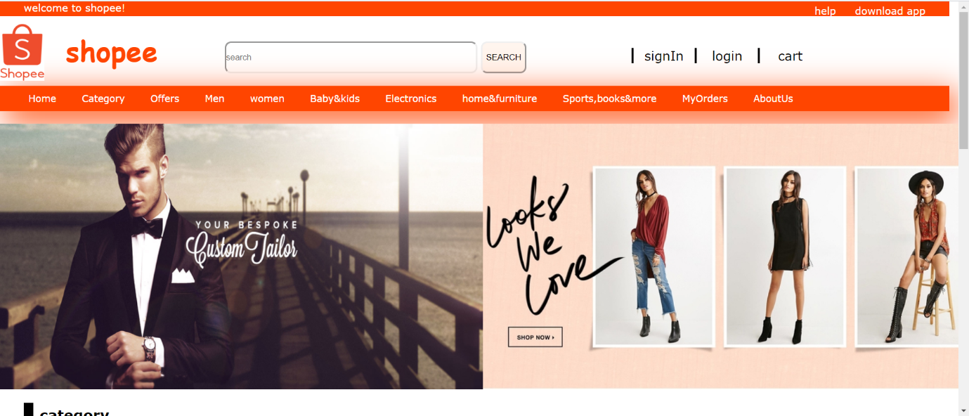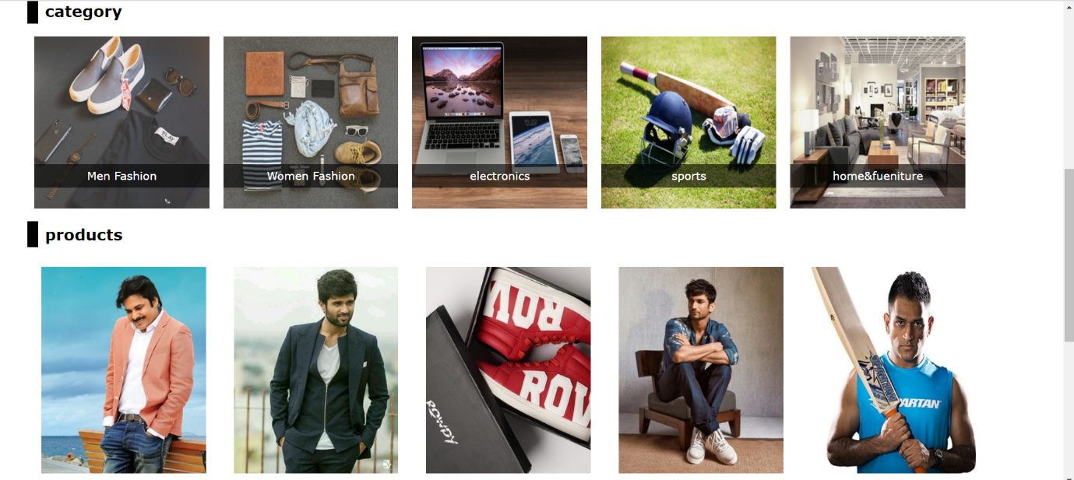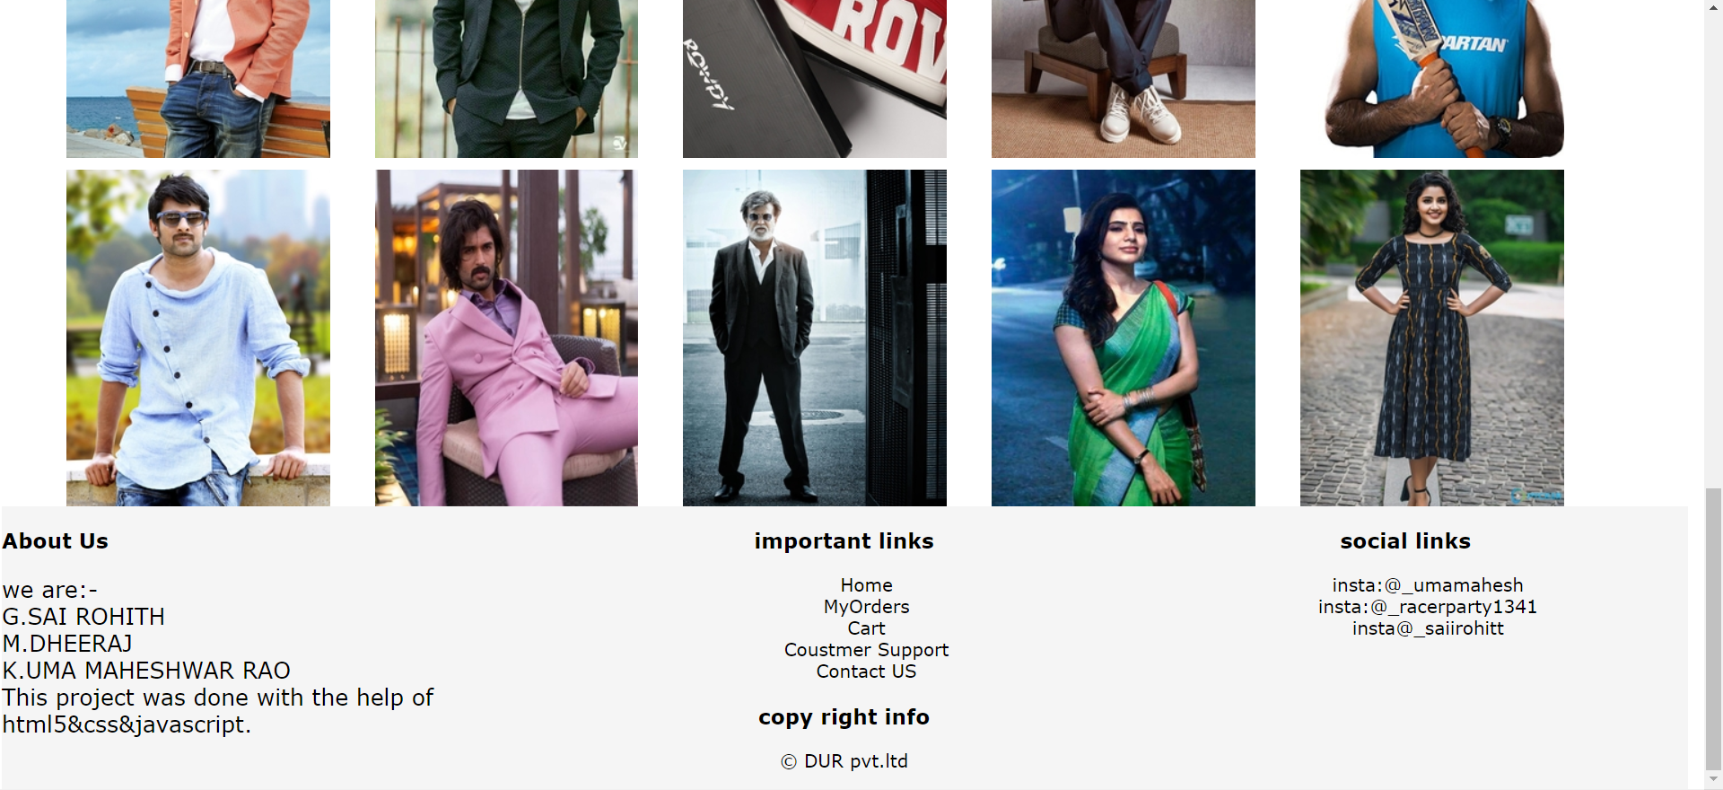

This are the screen shots of the web page we developed

HEADER:

* Header parts consist of logo and brand name at the top left corner and search bar at middle of the header part and sign in and login and cart at the top right corner
* Header has a logo of shopee
* Brand name of shopee
* Search bar styled with round corners
* Sign in ! login ! cart has mouse hover effects
* When we click on SignIn or login or cart it shows a alert message written with java script
* NAVIGATION BAR:-
* Navigation bar consists of few category and home button
* As per project module included my orders on the navigation bar
* Navigation bar has mouse hover effects and transition effects like (all .5s ease)
* In the navigation bar when we clicks on my orders it shows an action page that it should be done with .php language

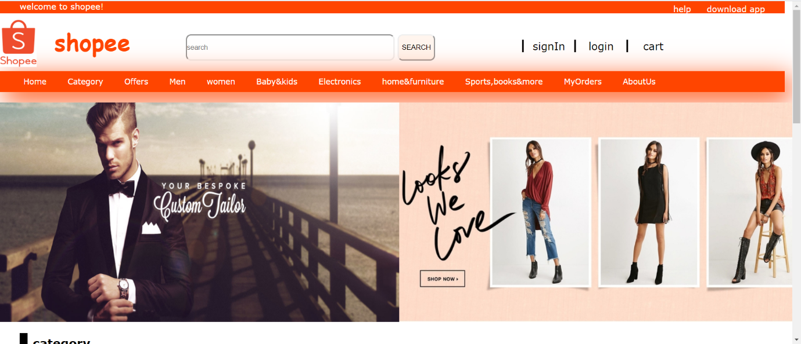

BANNER:-

* The banner is of a type slider but jquery files are required to make a slider like options
* The banner shows men and women fashion
* The banner made was static not slider
* No javascript written on the banner
* No click on picture feature is enabled on the banner
* Features done on banner was floating left and placing images side by side using css properties with id attribute
* 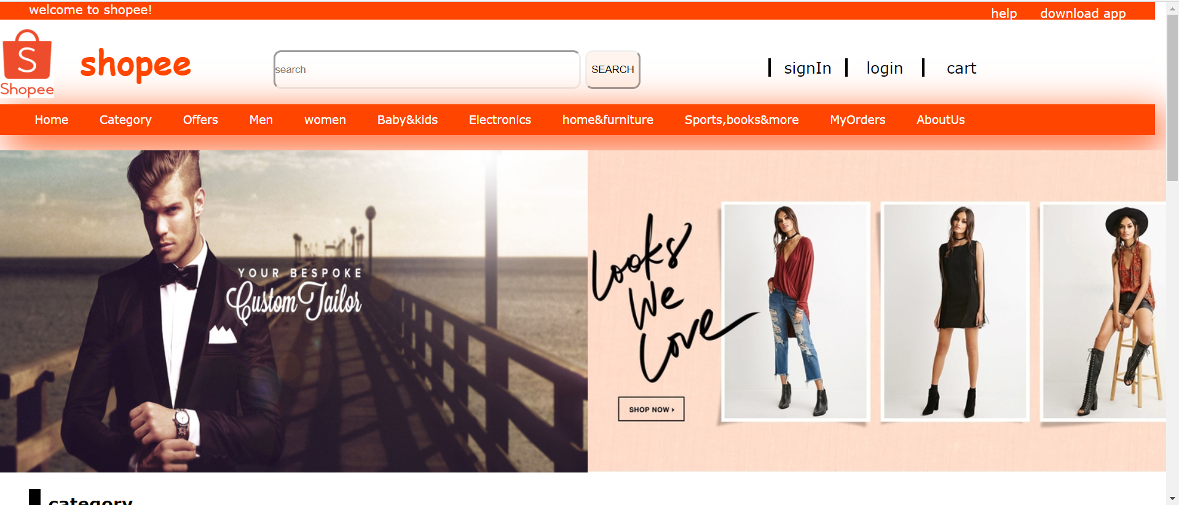

CATEGORY SECTION:-

* category section was the type of products which the coustmer wants to visit
* The tag was on the bottom of image with transparency back ground
* Every picture under category has mouse hover effects done with the help id and class attribute
* When we hover over the category products the background color the text in the tag changes
* No alert or picture clicks are enabled

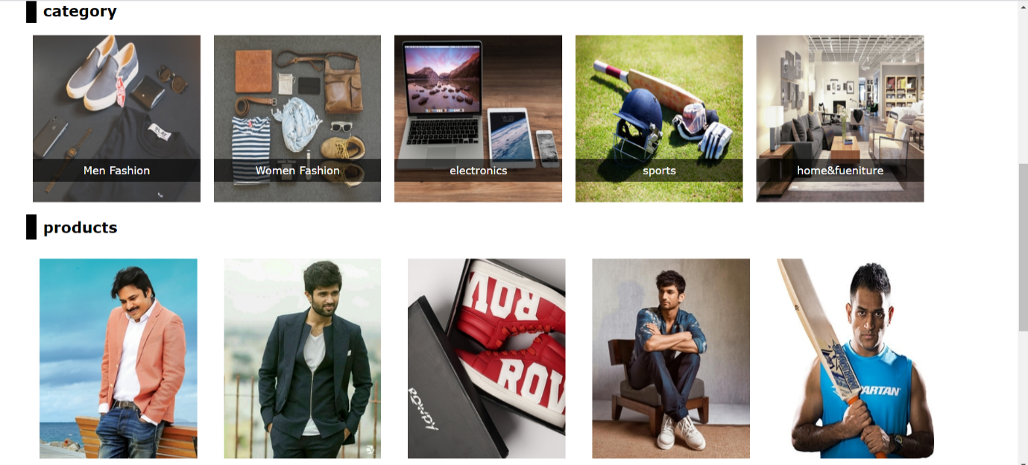

PRODUCTS SECTION:-

* Product section has ten products to view
* Products contain price tag
* Price and add to cart and buy now tags are visible when we hover over it
* All the products contain transition effect
* Both the product name and price text are different

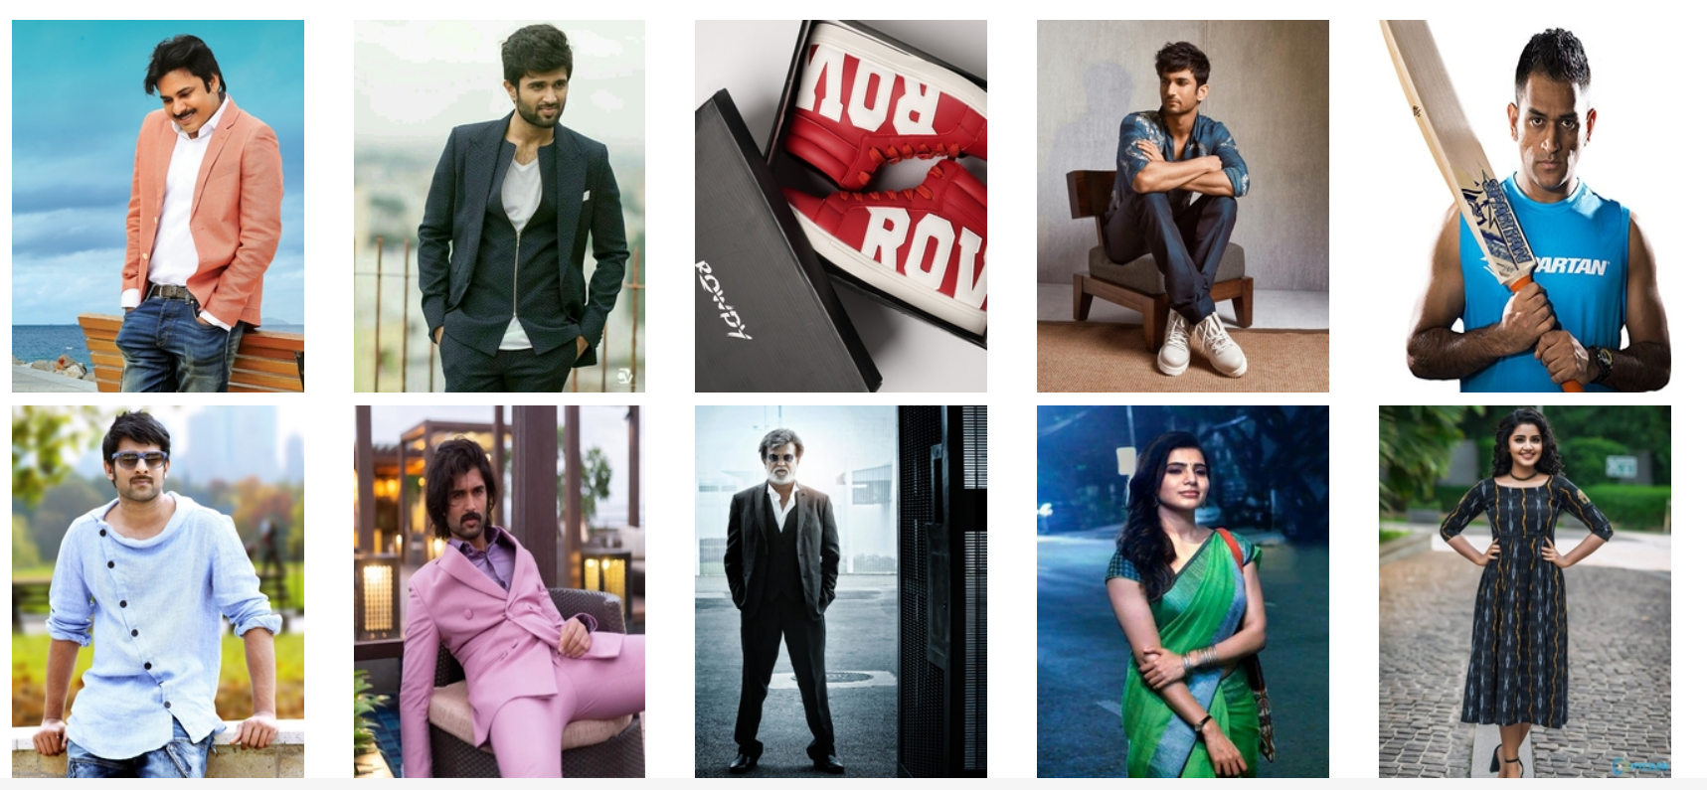

FOOTER SECTION:-

* Footer section contains four sub footer parts
* 1st footer part contains the about us part
* 2nd footer part contains important links of the developed web page
* 3rd footer part contains insta links of our developers
* 4th footer part contains copyright info

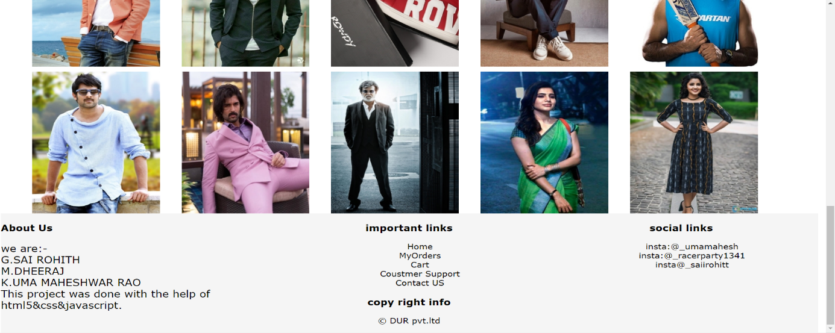

FINAL REPORT:-

* This website developed with the use of html &css

& javascript

* The web page was responsive
* All the css work was done internally
* The web page is just to view the products and all are visible buttons only no actions are furtherly taken.

This project was submitted to :-

DHANPRATAP SINGH

CSE326

K19PA

THANK YOU